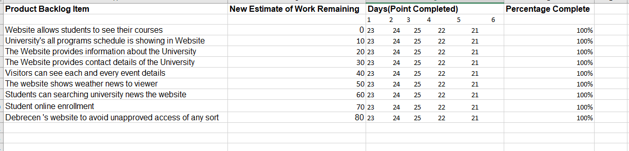
Figure 1 : Burndown Chart

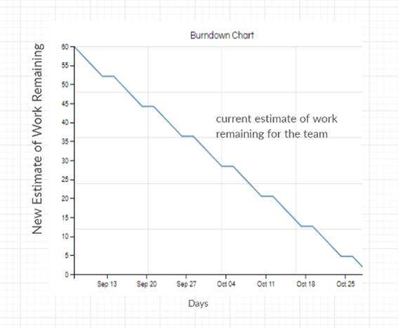
Figure 2 : Burndown Chart Graph

